Practicum 2: An Ecotoxicity test with *Daphnia magna*

2.1. Introduction

Contamination of the environment with chemical substances may cause effects on ecosystem structure and/or functioning. A profound knowledge of the impact of the degree of contamination on a range of organisms (e.g., plants, animals) is essential for performing risk assessment and to establish environmental quality criteria.

The effect of a certain chemical compound on an organism in the environment is dependent on a) the concentration of the compound in the environment, b) its bioavailability for uptake and further delivery to sites of toxic action, and c) the intrinsic sensitivity of the organisms in the contaminated ecosystem.

The relation between the concentration of a chemical in the environment and the effect (‘the response’) caused by this chemical in an organism is called the **concentration-response relationship** (please note that the term **dose-response relationship** is also often used, but this rather refers to internal doses, not external environmental concentrations).This relation is central in ecotoxicology and ecotoxicity tests are a commonly used instrument to investigate it. The purpose is to determine a range of selected and quantifiable effects in a group of test organisms of the same species that occur as a function of the concentration of the chemical to which they are being exposed under otherwise controlled conditions.

The **short term effects** of a chemical on an organism can be determined by means of an **acute toxicity test**. Generally, the exposure period of an acute toxicity test is only a **short period** (only a small fraction of the total life cycle of the test organism). Mortality and immobility are the most important endpoints used in acute toxicity testing. The most used and internationally accepted freshwater acute toxicity test is the acute 24 or 48 hour immobility test with the **water flea *Daphnia magna***. Also the 96 hour toxicity test with fish (such as *Danio rerio* and *Pimephales promelas*) is often used. These tests are extensively described in OECD Test Guidelines.

This practicum consists of two parts. In a first part (WETLAB) acute ecotoxicity tests with *Daphnia magna* are carried out to obtain **concentration-response data**. In the second part (PCLABs), the **concentration-response curve** will be fitted to those data and the **median effective concentration (EC50)** will be estimated. This EC50 will further be used in practicum 4 to carry out a local risk characterization of the tested substances following REACH principles.

## 2.2. WETLAB: Ecotoxicity test with *Daphnia magna*

**2.2.1. Purpose**

The purpose of this exercise is to determine the 48h EC50 of three different chemical substances for *Daphnia magna*. The test is based on OECD Test Guideline 202. Similar as in the biodegradation practicum, it should be noted that two substances (i.e. Dreft, Ecover) are in fact ‘products’ containing a mixture of a range of chemical substances, but in this practicum (and also further on, see practicum 4) we will treat them as if they were single chemical substances.

**2.2.2. Materials**

Test organisms: Daphnia magna, younger than 24h. In the Laboratory for Environmental Toxicology and Aquatic Ecology, a monoclonal population of this species has been cultured continuously for about 30 years by parthenogenetic reproduction. This culture (clone K6) was once started from a single adult organism and was selected out of a range of other monoclonal cultures for its optimal growth and asexual reproduction. This K6 clone has been used in many research projects since then. Advantages of D. magna as a test species are:

* The relatively high sensitivity of *D. magna* for a wide range of chemicals
* Possibility of working with genetically identical organisms (parthenogenetic reproduction), which reduces variability and increases reproducibility
* Ecologically important and representative for freshwater environments
* Size (juveniles ~1mm, adults ~4 mm) and generation time (~7-10 days) are optimal for the performance of acute and chronic ecotoxicity tests
* Abundant, widespread organism
* Large database with toxicity data for this species is available;
* Production and conservation of ephippia (dormant eggs) can take away the necessity of continuous culturing.
* 24 glass test bottles of 25 mL
* wooden board with cavities to hold the test bottles
* 2 plastic pipettes for transferring the organisms
* pipettes to make the dilution series
* 6 cylinders or flasks of 100 mL to make the dilution series
* tape and pen to mark the test and the test bottles
* test medium (prepared in advance):
* Parafilm
* stock solutions of the test substances (prepared in the test medium): 1 g/L and 10g/L Dreft, 1 g/L and 10g/L Ecover, 100 g/L NaOAc

### 

The organisms can be found in an aquarium in the practicum room. Each group needs 180 organisms in total. Transfer approximately this number of organisms with a plastic pipette from the aquarium into a glass beaker

**2.2.3. Stepwise protocol**

1. **Make a dilution series**

* Mark the cylinders (C0 = control; C1 = lowest concentration; C5 = highest concentration)
* Fill the cylinders until they are about half full (+/- 50 mL)
* Add the appropriate volume of stock solution to get the final chemical concentration, so that the desired final concentration is achieved when the cylinder is further filled with medium (up to 100 mL). The desired final concentrations can be found in table 2.1. In table 2.2 you can fill in the amount of stock solution needed to get the desired final concentration in a solution of 100 mL. Do this first and show the calculated values to a tutor before adding the stock solution.

Table 2.1 Test concentrations of the different substances in the *Daphnia*-test

|  |  |  |  |  |  |  |
| --- | --- | --- | --- | --- | --- | --- |
|  | **C0** | **C1** | **C2** | **C3** | **C4** | **C5** |
| **Ecover (mg/L)** | 0 | 32 | 56 | 100 | 180 | 320 |
| **Dreft (mg/L)** | 0 | 32 | 56 | 100 | 180 | 320 |
| **NaOAc (g/L)** | 0 | 1 | 1.8 | 3.2 | 5.6 | 10 |

Table 2.2 Quantity of stock solution needed for a total volume of 100 mL

|  |  |
| --- | --- |
| **Concentration** | **Quantity of stock solution needed for a total volume of 100 mL** |
| C0 = medium | …….mL |
| C1 = | …….mL |
| C2 = | …….mL |
| C3 = | …….mL |
| C4 = | …….mL |
| C5 = | …….mL |

* Fill the cylinders or flasks up to the 100 mL mark line;
* Cover with parafilm and shake gently.

1. **Setting up the test**
   * Place 18 bottles into the wooden holder + 1 row of bottles in front (“rinsing bottles”) (4 × 6 configuration)
   * Mark the concentrations with tape and pen on the wooden holder, also indicate the test substance and your group number
   * Fill the first column (the 4 most left bottles) with 25 mL of control medium (C0)
   * The second column is filled with the lowest concentration (=C1) and so on, up to the last column (=C5)
   * Take approximately 40 organisms from the beaker with juvenile *D. magna* with the plastic pipette and transfer them into the “rinsing bottle” of the blanco (C0). Make sure the tip of the pipette is below the surface of the liquid. Do exactly the same for the other “rinsing vessels”, working from low (C1) to high (C5) concentrations
   * Using a plastic pipette that has not been exposed to the tests substance, transfer exactly 10 daphnids from the blanco “rinsing” bottle into each of the three replicate bottles of the blanco. Make sure the tip of the pipette is under the surface of the liquid when releasing the daphnids
   * Repeat this procedure for all concentrations (low to high)
   * Cover the vessels with a plastic plate
   * Mark your test with name, date, time and test substance. The test will be placed in a thermostatic room at 20 °C, with a light cycle of 16hLight:8hDark
2. **Scoring of the test**

After 48 hours of incubation, the test will be scored:

* Take a bottle from the test set-up and swirl gently to mix
* Keep the bottle under an angle against a white background or a light and look at the organisms from upside, so that you can see all of them in one view (see figure 2.1)
* Count for each replicate the number of immobile organisms (those that do not actively move during 10 seconds (and also count the number of mobile organism, to check if you have actually added 10 animals at the start of the test).
* Attention: Immobile (=not actively moving) is not the same as dead (=no heartbeat)! This is also why result of this test (after data treatment) will be called an ECB50 ((median Effective Concentration) and not an LCB50B (median **L**ethal **C**oncentration). **The results are to be filled out in table 2.3.**

**Figure 2.1. How to score an acute daphnia test**

### 2.2.4. Reporting the concentration-response data

The test results are not valid when more than 10% mortality is observed in the control group. After scoring, table 2.3 is uploaded using the **format available on Minerva**. Use dropbox to submit your results to Olivier Berteloot. Clearly mention your group number, names and test substance in the name of the file. The data treatment will happen in the PCLAB “Data processing toxicity”, so **submit your results the evening of the day the test was scored.**

Table 2.3 Immobility in *D. magna* after 48 hours of exposure

|  |  |  |  |  |  |  |
| --- | --- | --- | --- | --- | --- | --- |
|  | Toxicant: …… | | | | | |
|  | Control | C1= | C2= | C3= | C4= | C5= |
| Replicate 1 | ……../10 | ……../10 | ……../10 | ……../10 | ……../10 | ……../10 |
| Replicate 2 | ……../10 | ……../10 | ……../10 | ……../10 | ……../10 | ……../10 |
| Replicate 3 | ……../10 | ……../10 | ……../10 | ……../10 | ……../10 | ……../10 |
| Total | ……../30 | ……../30 | ……../30 | ……../30 | ……../30 | ……../30 |
| % immobility |  |  |  |  |  |  |

2.3. PCLAB: Determination of the 48h-EC50

2.3.1. The concentration – response curve

The results of the scoring of the ecotoxicity tests during the wetlab “Ecotoxicity test” are used to estimate the concentration that causes an effect (immobility) in 50% of the test organisms, also called the **median effective concentration or EC50**. In determining the acute toxicity of a chemical, this 50% effect level is often preferred above lower values (e.g., 5% or 10%)because the confidence intervals at 50% effect are most often narrower than those at lower effect levels (i.e. the estimates are more *precise*. Thus, the 50% effect level is often chosen in acute toxicity estimation because of this practical consideration. When the concentration-response data of the immobility tests from practicum 2 are set out in a graph, typically an S-shaped **concentration-response curve** can be fitted to the data (figure 2.2).



Figure 2.2 Hypothetical concentration-response data (diamonds) and a fitted S-shaped (or sigmoid) concentration-response curve (line)

Usually, mathematical techniques like regression analysis are used to obtain an estimate of the EC50. Due to the variation in sensitivity among the tested organisms, there will always be some degree of uncertainty concerning the true value of the EC50. This uncertainty can be expressed by means of confidence intervals, which provide the range of values within which the true EC50issituated. For instance, a 95% confidence interval can be interpreted as the range of values within which the true EC50 for the entire population is situated with 95% certainty.

2.3.2. Transformation of the concentration and effect data

Before the availability of advanced statistics software, ecotoxicologists often relied on data transformation followed by simple linear regression analysis to estimate EC50 values.By means of certain transformations the concentrations and effects are transformed to **metameters**,between which a linear relationship exists. The most used metameter for concentration is the logarithm of the concentration, log(concentration). Which metameter will be used for the effect, depends on the model that is assumed to underlie the relation between log(concentration) and effect. Nowadays, statistics software is available, which makes these transformations unnecessary. However, from a didactic point of view, these transformations are still very interesting to know about.

An often used metameter in environmental toxicology is the **probit**. One assumes that the S-shaped graph of effect as a function of log(concentration) is described by a cumulative normal distribution function. The most cited theoretical basis of this is the ***Individual Effective Dose (IED) model***. Under this model the shape of the curve (cumulative normal distribution function) originates from a log-normal distribution of such individual effective doses(see Theory – Chapter 4). Please note though, that the competing theory, the ***Stochastic Model***, can also explain why the concentration response data would follow the cumulative normal distribution function.The probit is based on the NED (*Normal Equivalent Deviation*). This is the fraction of dead (or immobile) organisms (P), expressed as units of standard deviation from the mean of a standard normal distribution. For a fraction of dead organisms corresponding to the mean (i.e. 50% of the organisms, P=0.5) the NED = 0. For a fraction of dead organism corresponding to one standard deviation below the mean (16% dead/immobile organisms) the NED = -1. To avoid having to deal with negative values, a value of five is added to each NED, which yields in the probit (see Theory – Chapter 4 – for more details).

1. Probit(P) = NED(P) + 5

The NED can be easily calculated in Excel with the function NORM.INV (P, 0, 1), when you take mean = 0 and standard deviation = 1.

The **logit** is a metameter which is used when the cumulative logistic distribution function (briefly ‘the logistic curve’) is assumed to describe the S-shaped curve of effect versus log(concentration). Following the IED theory this would be equivalent to assuming that the individual effective doses are log-logistically distributed within the population. The logit of the fraction of dead/immobile organisms (P), is given by:

1. 

This metameter is somewhat easier to calculate than the probit, and usually also exhibits a linear relationship with log (concentration). For P between 0.3 and 0.7, the logistic curve is nearly parallel to the cumulative normal distribution curve. The transformed logit is also used often because it brings the value of the logit very close to the value of the probit, except at the extreme ends of the curves:

1. Transformed Logit(P) = Logit(P)/2 + 5

There is no theoretical basis for preferring either the logit or the probit transformation. Often, the transformation that results in the best linearization of the concentration response data, is preferred (i.e. for which the linear regression yields the highest correlation coefficient). Important to note is that both metameters can only be used to determine an EC50from simple linear regression when there are at least two test concentrations with partial mortalities (or immobility’s). This is because the probit nor the logit can be calculated if P=0 or P=1.

A third metameter for the effect is the angle transformation, which can be used in cases where only a single partial mortality is observed:

1. Angle(P) = Arcsin()

### 2.3.3. Software

Different types of software are available to analyze your results. For didactic purposes we selected two of them.

* In the first approach, Excel is used to manually determine the EC50 values from your concentration response data, after linearization using the methods explained in 2.3.2.
* In a second approach, the calculation of concentration-response curve is implemented through the extension package **drc** for the open source statistical software R, which is developed by the R Project for Statistical Computing (http://www.r-project.org). This software is freely available and provides a flexible platform. The main advantage is that the package also allows to calculate confidence intervals on the estimated EC50 values.

### 2.3.3.1.Calculation in Excel

Determine the EC50 for the toxicity tests performed during the WETLAB. The data can be found on the Minerva website in the documents section. Use Excel to make these calculations. Compare the EC50 values found between two groups with the same test substance (Dreft, Ecover, NaOAc). If there is a difference, indicate which EC50 is the best in your opinion.

1. When you have two or more partial immobilities:
   * Transform the concentration to log(concentration)
   * Transform the effects to logits
   * Calculate the EC50 via linear regression
2. When you have only one partial immobility:
   * Transform the concentration to log(concentration)
   * Transform the effects with the Arcsin transformation
   * Calculate the EC50 via linear regression based on the highest concentration with 0% immobility, the concentration with partial immobility and the lowest concentration with 100% immobility
3. When you have no partial immobility:

Calculate the EC50 with the binomial method as researchers pointed out that partial mortality is not always necessary to make an estimate of L(E)C50 and the corresponding 95% confidence intervals. They supposed that the L(E)C50 has to be between the highest concentration resulting in 0% mortality (A) and the lowest concentration resulting in 100% mortality (B). This is only valid when the sample error is assumed insignificant. The estimate of the LC50 is the geometric mean of the two concentrations A and B:

1. EC50 = (A*B)1/2

where A and B are expressed in concentration units. The interval between A and B can be used as an approximation of the 95% confidence interval.

*2.3.3.2.Calculation in R*

**Step 1:**

Open Rstudio via Athena in the folder “Main”, subfolder “Academic”, ignore the update.

You now get the screen below. The left, large window is the **R-console** here you can write down your commands. The top right window is your current **Workspace**, here you will see the parameters, vectors, matrices, datasets etc. that you have defined, their dimensions and characteristics. In the bottom right window you can verify in which **folder** (first tab) you are working (typically one at your H-drive of the UGENT), and you can visualise your **plots** (second tap).

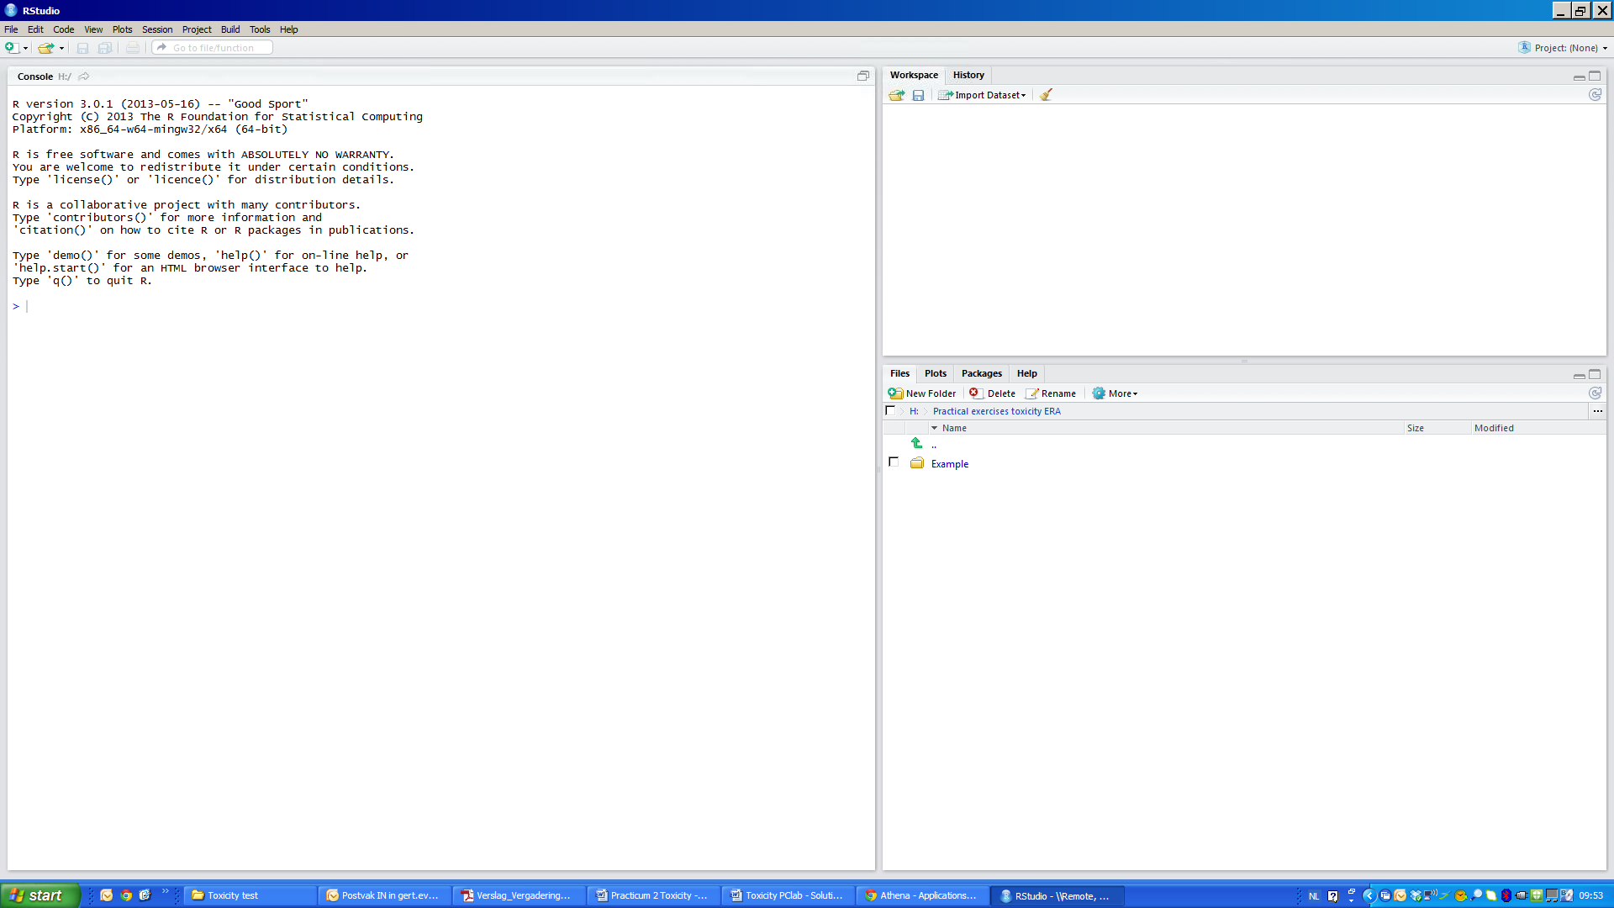

**Workspace**



**plots**

**Folders**

**Step 2:**

If you write down a list of command in the R-console it can be difficult to store them in a proper way because sometimes you can have typo’s, miscalculations or errors reported. In order to store your scripts nicely, a **R-script** window was created.

Click on “File” and select “New” 🡺 “R script”.

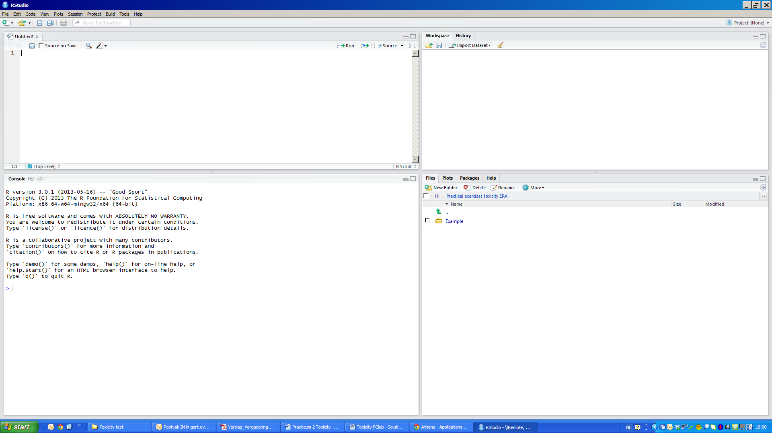You now get the screen below. You see that the left window is split in two, the bottom left window is still your **R-console**. In the top right window you write down your commands and you can run them via clicking on the “**Run-button**”

**Script window**



**Script window**

**Step 3:**

A simple example. We define two vectors composed of three numeric values in the R-script window. **Vector a** consisting of the values 2, 5 and 10 and **vector b** being 3, 6 and 15. Note the “special” sign to define an element in R. Click on the “Run-button”.

You now get the screen below. You see that your commands are send from the **R-script** window to the **R-console** and that you have defined two vectors a and b in your current **Workspace**.

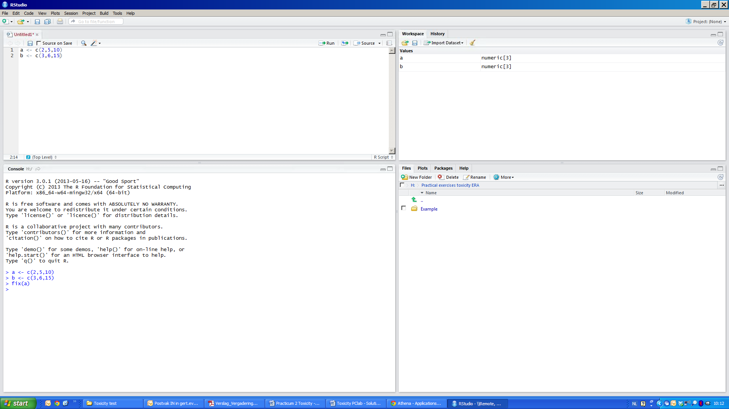

**Run button**



**Result**

**Executed**

**script**

**Step 4:**

An easy calculation. You can now calculate the sum between vector a and b and define it as vector d. To see the result of this command, just write down “d” in the **R-script window** and click on the “Run-button”. You can save your R-script (the top left window) via “File” and select “Save”. Use the appropriate folder and name your script.

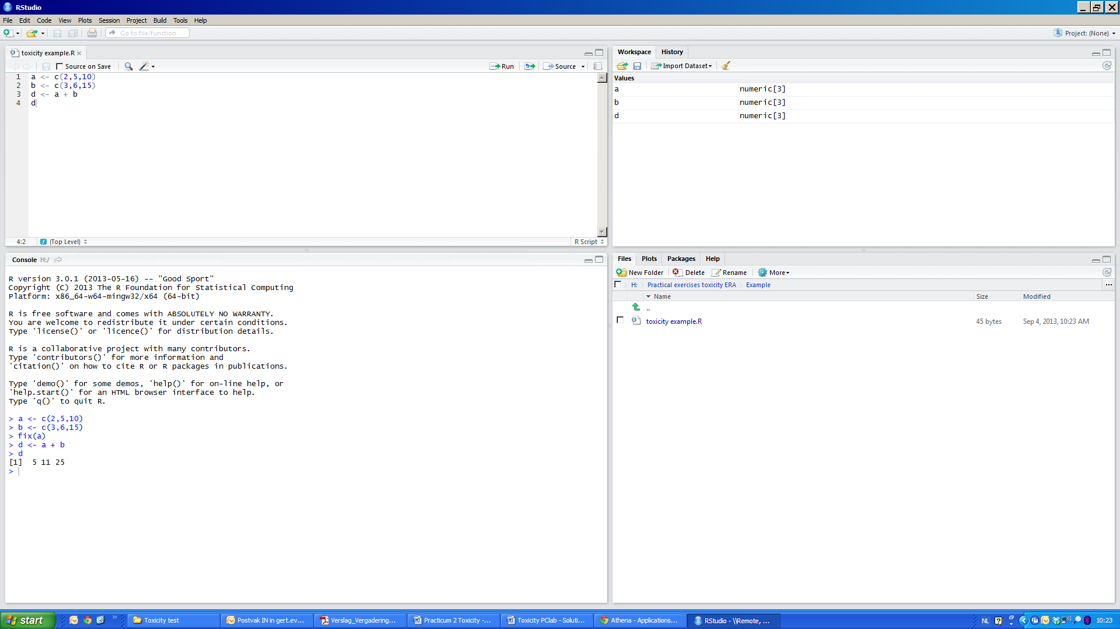



**Step 5:**

The package ‘**drc**’ includes a function for fitting concentration/dose/time-response models to data. Install the package ‘**drc**’by entering the command line below in the R script and click on the “Run-symbol”

*> library(drc)*

**Step 6:**

Create three vectors containing the test concentrations, the number of dead/immobile daphnids and the total number of tested daphnids per concentration.

*>concentration <-c(…) # tested concentrations in mg/L*

*> response <- c(…) # number of dead/immobile daphnids*

*>number.of.tested.daphnids <- c(…) #total number of tested daphnids*

Get a first impression of your data by using the **plot** function.First search for some information on this plot function and check what should be on the x and y-axis.

*> ?plot*

*>plot(concentration, response)*

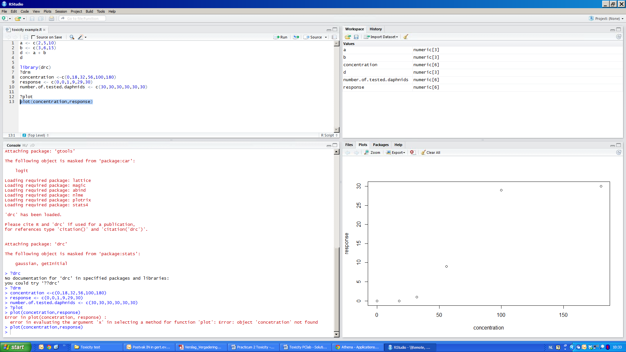



**Step 7:**

To fit a dose-response model to the acute toxicity data, we use the function **drm.** For more information on the function **drm**, write

*> ?drm*

**Step 8:**

In the function **drm**, the response is specified on the left side of the tilde (~) as the proportion of dead/immobile daphnids. The independent variable containing the concentrations (dose) is given to the right of the tilde. Important here is that we have to specify which dose-response model we want to fit to our acute toxicity data. Model **LL.2()** is the label for the **two-parameter log-logistic model,** which specifies that the lower limit is fixed to 0 and the upper limit fixed to 1. The model has two parameters: a parameter for the EC50 level and a parameter for the relative slope at the EC50 level and can be defined as

With:

x= tested concentrations

α4 = EC50 level = e

α1 = relative slope at the EC50 level

The argument **type** indicates the type of response to be analyzed

*> m1 <- drm(response/number.of.tested.daphnids*~ *concentration, fct =LL.2(), type="binomial")*

**Step 9:**

A plot of the acute toxicity data and the fitted dose-response curve is obtained using the **plot** method (see example figure 2.3). See the change per extra item added to the script (see also figure 3.2).

*>plot(m1)*

*>plot(m1, broken=TRUE)*

*>plot(m1, broken=TRUE,xlab =" Concentration substance X (mg/L)",ylab ="Fraction of dead/immobile daphnids")*

**Step 10:**

A summary of the fit, including estimated parameters and their standard errors, is obtained using the **summary** method applied to the model **m1**.

>*summary(m1)*

You will obtain a result similar to the one below.

*Model fitted:*

*Log-logistic (ED50 as parameter) with lower limit at 0 and upper limit at 1 (2 parms)*

*Parameter estimates:*

*Estimate Std. Error t-value p-value*

*b:(Intercept) -6.3230 6.9460 -0.9103 0.3627*

*e:(Intercept) 62.4233 18.7019 3.3378 0.0008*

The t-values and p-values are for testing the null hypothesis that the corresponding parameter is equal to 0. Information on the type of model fitted and the estimated residual variance is also given. The *e* parameter is the **estimated EC50 value.** Compare these EC50 values with those obtained via the manual calculation in Excel.

**Step 11:**

The function **ED** calculates effect concentrations of your choice, as one can be interested in other effect levels than just the 50% effect level. For instance the EC10 and EC90 valuesbased on model fit **m1** are estimated by writing:

*>ED(m1, c(10, 50, 90) )*

You will obtain a result similar to the one below.

*Estimated effective doses*

*Estimate Std. Error*

*1:10 44.099 19.849*

*1:50 62.423 18.702*

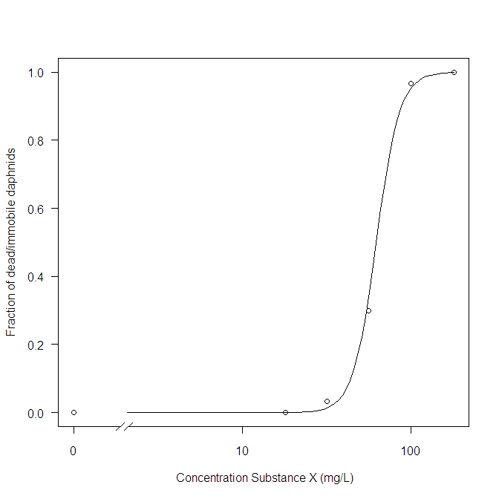*1:90 88.361 45.776*

**Figure 2.3 Fitted concentration-response curve**