# Practicum 5: Bioconcentration of polycyclic aromatic hydrocarbons (PAHs)

## 5.1. Introduction

The extent of bioaccumulation of a chemical in a test organism at a given time is the combined result of the processes of **uptake, distribution, transformation and excretion**. If the chemical is available for uptake by the organism over a sufficient amount of time these four processes will ultimately result in a **dynamic equilibrium** (apparent plateau or steady-state), which is characterised by a constant ratio of the concentration of the chemical in the test organism over the concentration in the ambient medium (e.g. water) (Figure 5.1).

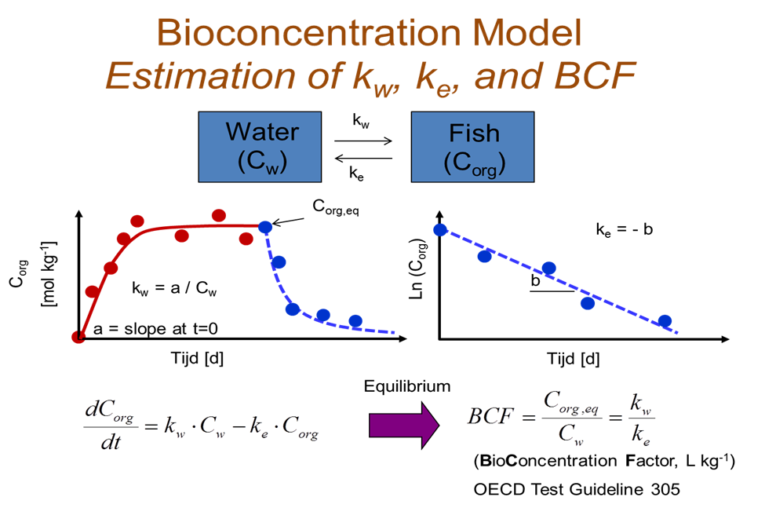

**Figure 5.1 The equilibrium or steady-state concentration (Corg,eq or Corg,SS) in the organism is reached when uptake and elimination rate become equal.**

The bioconcentration factor (BCF) of a lipophilic compound is defined as the ratio of the steady state concentration in the body of an aquatic organism to the concentration in the surrounding water. It is a measure of the **tendency of lipophilic organic pollutants to accumulate in aquatic organisms**. There is a clear correlation between bioconcentration and lipophilicity [expressed as partition coefficient (n-octanol/water) = Kow] of non-ionised organic chemicals. Therefore, the partition coefficient (Kow) may be regarded as a good predictor of the BCF especially for chemicals with a logKow between approximately 2 and 6 Figure 5.2).



**Figure 5.2 The relationship between the logarithmic value of the bioconcentration factor (= log KB = log BCF) and the log Kow value based on bioaccumulation tests of hydrophobic chemicals in fish (from Connell and Hawker, 1988).**

## 5.2. General equations

A general aquatic bioconcentration model can be described in terms of uptake and loss processes, while ignoring uptake with food, growth and metabolic transformation of the test chemical. The **differential equation** (dCorg/dt) that describes the rate of change of the chemical in the biota (mg kg-1 day-1) is given by:

(1)

where kw = First order rate constant for uptake into biota (L / (kg · day))

ke = First order rate constant for elimination from biota (1 / day)

Cw = Concentration in water (mg / L)

Corg = Concentration in biota (mg / kg wet weight).

At steady-state (SS), the **rate of uptake equals the rate of elimination**, and so

(2)

where Corg,SS = Concentration in biota at steady-state (mg / kg wet weight).

Cw,SS = Concentration in water at steady-state (mg / L).

The steady state bioconcentration factor (BCFSS) is calculated as the ratio of the concentration of a chemical in biota (Corg,SS) over the concentration of this chemical in the water (Cw,SS) at steady-state. Alternatively, it can be estimated as the ratio of the rate constant of uptake (kw) over the rate constant of depuration (ke), assuming first order kinetics. Then it is called the kinetic bioconcentration factor (BCFK).

For some biota (e.g. fish) an estimate of ke may be obtained from empirical relationships. Here the value for ke is calculated from the n-octanol/water partition coefficient (Kow) (3) or kw and BCF (4) following OECD test guideline 305. It should be emphasized, however, that the equations only apply when uptake and elimination follow **first-order kinetics** and that those empirical relationships are not available for all species.

(3)

or

(4)

The time needed to reach a certain percentage of the steady-state concentration may be obtained by applying the ke-estimate (eq. 3) to the general kinetic equation (eq. 1). Assume that Cw is constant and that the steady-state has been reached. Taking into account that BCF × Cw equals the concentration in the biota at steady-state (Corg,SS), equation 1 then becomes:

(5)

From equation 5 it is possible to calculate the estimated time needed to reach a certain percentage of the steady-state.

## 5.3. WETLAB (Video): Bioconcentration of PAHs in the blue mussel

**3.5.1. Principle of the test**

Marine organisms like filter feeder mussels (*Mytilus edulis*) have a high ability to accumulate PAHs because they have no efficient system to metabolize them. The **purpose of this study** is to determine bioconcentration factors of two PAHs based on an experiment in which mussels are exposed to a test chemical in an aqueous solution. A typical bio-accumulation test consists of two phases: the exposure (uptake) and post-exposure (depuration or elimination) phase. During the uptake phase, a group of mussels is exposed to the test chemical at one or more chosen concentrations, depending on the properties of the test chemical. They are then transferred to a medium free of the test chemical for the depuration phase. The concentration of the test chemical in the mussel is measured through both phases of the test. In addition to the exposed group, a control group of mussels is held under identical conditions except for the absence of the test chemical, to obtain background concentrations of test chemical. In the aqueous exposure test, the uptake phase is usually run for several days (for fish 28-60 days). The duration can be shortened if it is demonstrated that steady-state is reached earlier. Tests have shown that steady-state in mussels is reached after 3 to 4 days (Figure 5.3).

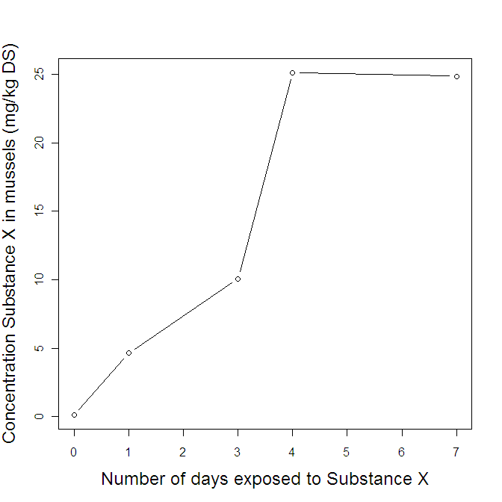

**Figure 5.3 When exposing mussels to a chemical like benzo[a]anthracene (BAA) or fluorene (FLU), the steady-state between the mussel and the seawater is typically reached after 3 to 4 days (typical data are shown)**

**5.3.2. Passive dosing (further information Smith et al., 2010)**

The most straightforward and easiest way to expose mussels to the test chemical is by simply **spiking** the chemical in the water. When following this approach one calculates the theoretical spike concentration, adds this to the test vessel and assumes that the test concentration remains constant. However, lab experiments using PAHs can be biased due to compound losses through volatilization, sorption to the walls of the test vessels and accumulation in the test organisms.

Different dosing approaches can provide constant dissolved PAH exposure concentrations during aquatic assays. The simplest approach is **careful test design** to minimize losses. In cases of only moderate test chemical loss, periodical renewal of the exposure medium might be sufficient to maintain exposure concentrations within acceptable ranges. However, if losses are more severe, a more rapid and continuous resupply of the test chemical is necessary. This can be achieved with **flow-through** systems, which are commonly used for toxicity and bioconcentration testing with fish. Although such flow-through systems are feasible, they are difficult to apply in aquatic tests with small organisms such as bacteria, algae and zooplankton. An alternative approach to achieve constant exposure in such cases is **passive dosing**, also referred to as partitioning based dosing or partition controlled delivery.

Passive dosing is the continuous partitioning of PAHs from a biologically inert polymer into the water, providing well-defined and constant freely dissolved concentrations. The low cost of materials and its simplicity make passive dosing ideal for aquatic toxicity or bioconcentration tests in relatively small vessels. It is thus particularly suited for aquatic tests with, for example, invertebrates or algae.

**5.3.3. Practical exercise**

Based on the experimental design beneath you obtain the necessary data to calculate the BCF of PAHs. Essentially, ten steps need to be taken. We provide the data resulting from such experiment at Minerva.

**Step 1: Collect the test organisms**

Mussels (*Mytilus edulis*) were collected along the Belgian coast, cleaned and acclimatised to lab conditions (water temperature of 15°C and a salinity of 29-30 practical salinity units (PSU)).

**Step 2: Define the experimental design**

We will determine the BCF for two test chemicals (Table 5.1). Per chemical, one control treatment is foreseen and one low and one high concentration treatment (Table 5.2).

**Table 5.1 Test chemicals and their characteristics (based on Epiweb 4.1)**

|  |  |  |  |
| --- | --- | --- | --- |
| **Chemical** | **Abbreviation** | **Log Kow**  **(L water per L octanol)** | **Log Ksampler**  **(L water per**  **kg sampler)** |
| benzo-a-anthracene | BAA | 5.52 | 5.31 |
| fluorene | FLU | 4.02 | 3.79 |

**Table 5.2 Experimental design**

|  |  |  |  |
| --- | --- | --- | --- |
| **Experiment number** | **Chemical** | **Aqueous concentration** | **Amount of sampler needed (g)** |
| 1 | BAA | Control | 5  5  5  5  5  5 |
| 2,7 | BAA | Low |
| 3,8 | BAA | High |
|  |  |  |
| 4 | FLU | Control |
| 5,10 | FLU | Low |
| 6,9 | FLU | High |

**Step 3: Pre-load the passive samplers with PAHS**

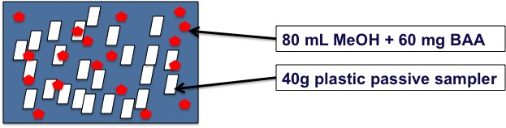

**Figure 5.4 Preloading of samplers**

**Step 4: Add pre-loaded sampler to artificial seawater**

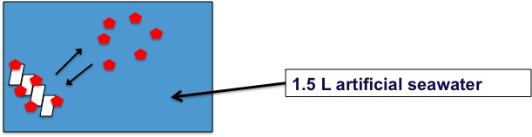

**Figure 5.5 Loading seawater**

**Step 5: Reach equilibrium between passive samplers and seawater**

After two days equilibrium conditions were assumed between the passive samplers and seawater.

**Step 6: Add mussels in PAH-enriched seawater**

During the experiment the test conditions were held constant at 15°C and a salinity of 29-30 PSU. Mussels are filter feeders, so during the lab experiment they were daily fed with 4 ml Shelfish Diet 1/10. Aeration is provided and after two days the seawater will be refreshed and a second water sample will be taken by the lab technicians. After four days the equilibrium conditions will be reached.

***Important note****: strictly speaking the presence of food during the exposure would also allow uptake of the chemicals in the mussels via the diet (after adsorption of absorption of the chemical on or in the added food); thus, we would in fact be measuring bioaccumulation (uptake from all sources, see theory for details) and not bioconcentration (only uptake from water considered); however, mussels have a sufficiently high clearance rate (i.e. the rate at which they clear a certain volume of water from all particles) to ensure that it can be assumed that most particles are eaten so rapidly that there is insufficient time for chemicals to become a dietary source of exposure via absorption or adsorption; indeed, clearance rates of the mussels used here are approximately 1 L hour-1 mussel-1, which means that 5 mussels together will eat most particles from the 1.5 L volume in approximately 20 minutes; thus, we can safely assume that what we are measuring is very close to bioconcentration.*

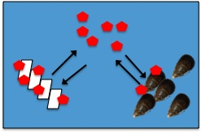

**Figure 5.5 General setup**

**Step 7: Extract the mussels from the seawater and dissect the digestive glands**

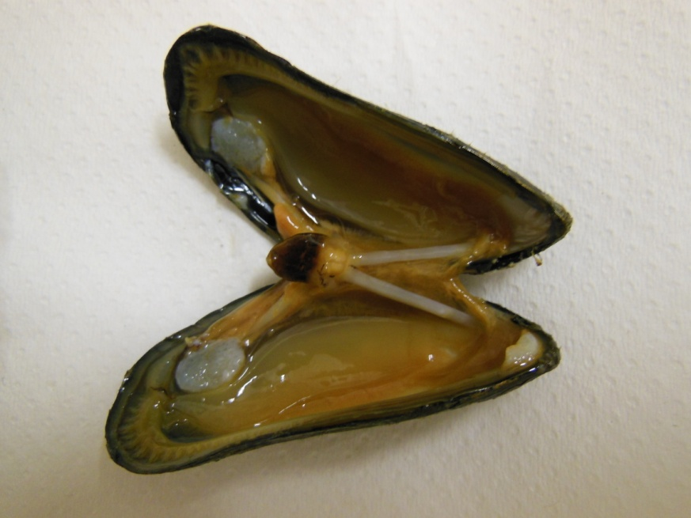

**Figure 5.6 Digestive glands of the mussel**

**Step 8: Homogenize the digestive glands**

**Step 9:Chemical analysis**

During the procedure explained below, several steps are to be taken. The general aim is to separate the PAH accumulated in the fatty tissue from the fat itself. In each step it is possible that some of the PAH is lost accidently. In order to be able to quantify this loss an isotopically labelled internal standard solution is added to the sample (e.g. deuterated acenaphthene or chrysene). This standard solution is expected to remain for 100% in the separated PAH fraction. In case if at the end of the procedure not all isotopically labelled internal standard solution is recovered, this is a measure to quantify the overall loss of PAH during the procedure.

* ***Saponification*** *– add MeOH/KOH*

Aim: PAHs and fat are soluble in apolar solvents. With a saponification reaction, the fat is made less apolar (provided that the analytes are very stable in the extreme alkaline reaction conditions).

During this phase the fatty matrix (triglycerides: esters of fatty acids), will be hydrolysed and the K-salt of the carboxylates will be formed. These are more soluble in polar solvents than the original products (fats) and the analytes (PAHs). With the difference in polarity, it is possible to separate the “hydrolysed” fats from the PAHs by liquid/liquid extraction.

* ***Extraction*** *– add hexane*

Aim: Extract PAHs from fatty matrix into organic solvent (hexane).Separate the hexane layer from the MeOH/KOH layer (Figure 5.7). After two steps it is expected that your MeOH/KOH layer does not contain PAHs anymore.

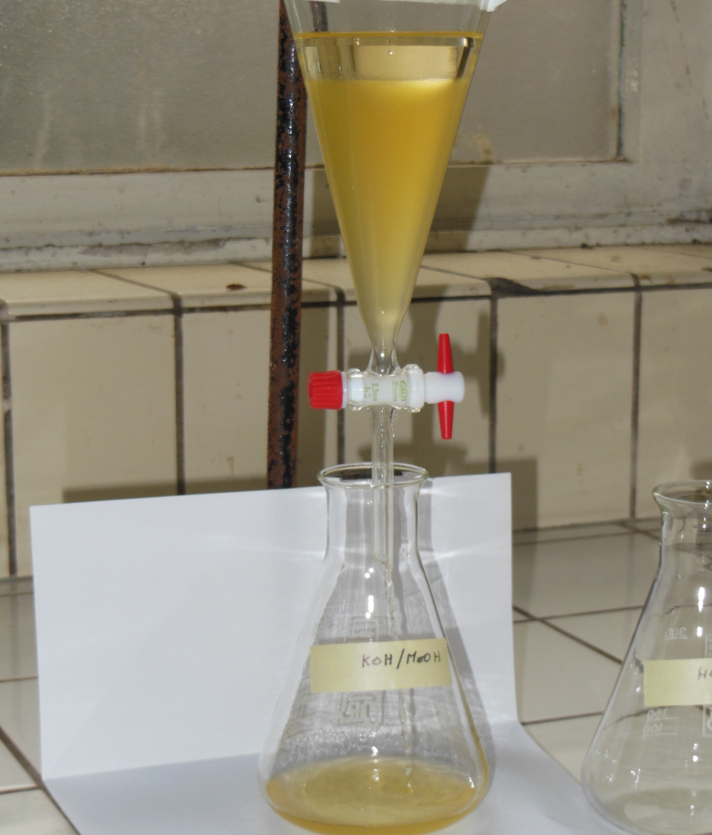

**Hexane layer containing PAHs**

**MeOH/Water layer containing fatty acids**

**Figure 5.7 Separation of the hexane layer from the MeOH/water layer**

* ***Washing –*** *add MeOH/water mixture*

Aim: Extract all leftover saponified material from hexane phase, using a polar solvent. In the hexane layer, there will still be some saponified material present. In this step you will extract them with a polar solvent (MeOH/water mixture; Figure 5.8).

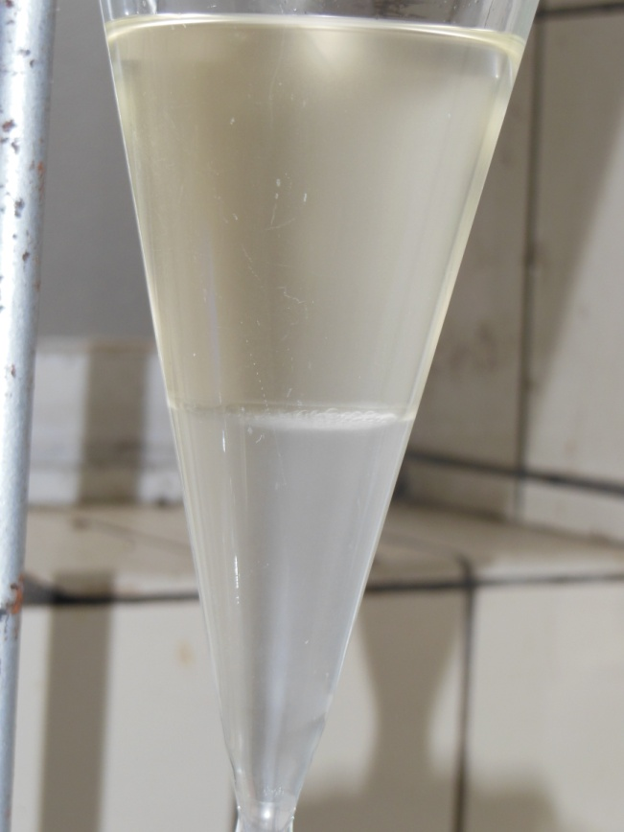

**MeOH/Water layer containing saponified materials**

**Hexane layer containing PAHs**

**Figure 5.8 Washing step**

* ***Evaporation***

Aim: Concentrate the hexane layer to 1 - 3mL via evaporation under vacuum conditions

* ***GC/MS analysis***

Aim: Gas chromatography (GC) is a technique to separate chemical components in a complex sample, based on different equilibria with packing material in a column. A fixed volume of the water sample or extract is injected into the GC/MS. At the end of the GC column, compounds are detected on a mass spectrometer (MS). The result of a GC/MS analysis is a chromatogram, with time on the X-axis and intensity (corresponding to the amount of detected substance) on the Y-axis (fig. 5.9). Each chemical substance has a specific retention time RT (i.e. the time at which it elutes out of the column). This is a first indication of the identity of the component. Moreover, the area of a peak on a chromatogram is proportional to the amount of the chemical substance being detected and hence to the concentration of the chemical in the solution which is injected.

* + The mass spectrometer can also identify compounds by ionizing them and breaking them down into ‘daughter compounds’, which are characterized by their mass over charge ratio (m/z). For each chromatographic peak in fig. 5.9a (corresponding to a specific chemical substance which elutes out of the column), a mass spectrum can be obtained, with m/z on the X-axis and intensity (corresponding to the amount of detected ion) on the Y-axis (fig. 5.10 and 5.11). These spectra are molecular ‘fingerprints’, which are very specific to each ‘parent compound’. You can also select key m/z ions for each parent compounds, and use these as a ‘filter’ in the chromatogram. Then, the peak areas in the chromatogram are only based on the detection of ions with the selected m/z (fig. 5.9b and c). Typical for PAHs is that the molecular ion is the most intense ion (fig. 5.10 and 5.11). Therefore quantification is based on these molecular ions (table 5.3).

**Table 5.3 Parameters for analysis of PAHs**

|  |  |  |  |  |
| --- | --- | --- | --- | --- |
| **Analyte** |  | Characteristic ions (m/z) | RT (min) | IS used for |
|  |  | Ions used for quantification | (17/09/12) | recovery |
|  |  |  |  |  |
| Acenaphthene-D10 | IS1 | 164 | 8.9 |  |
| Fluorene |  | 166 | 10.1 | IS1 |
| Fluoranthene-D10 | **RS** | 212 | 13.5 |  |
| Benzo(a)anthracene |  | 228 | 15.9 | IS2 |
| Chrysene-D12 | IS2 | 240 | 15.9 |  |

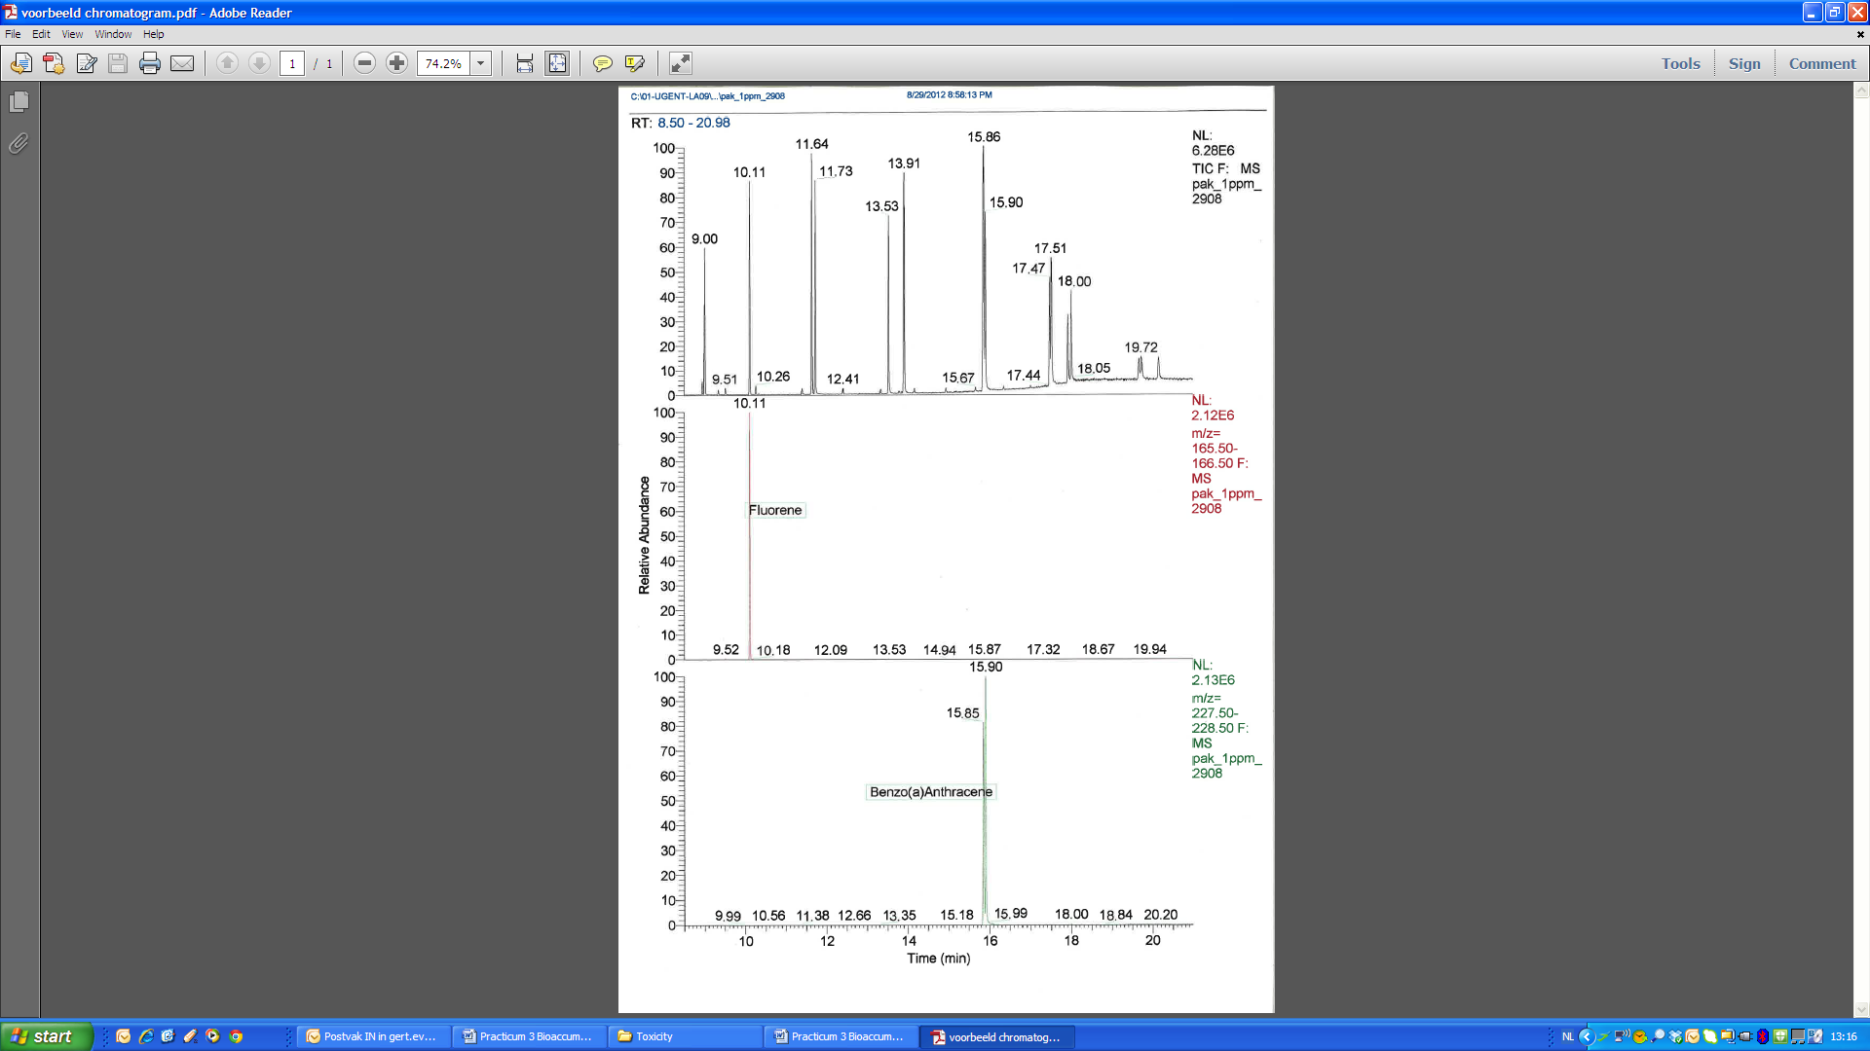

**Figure 5.9 Example of a chromatogram of a PAH analysis.**

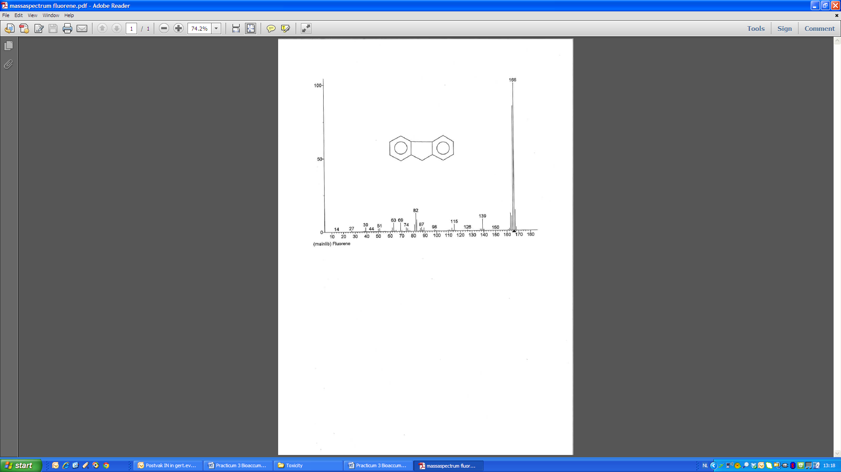

**Figure 5.10 MS-spectrum fluorene**

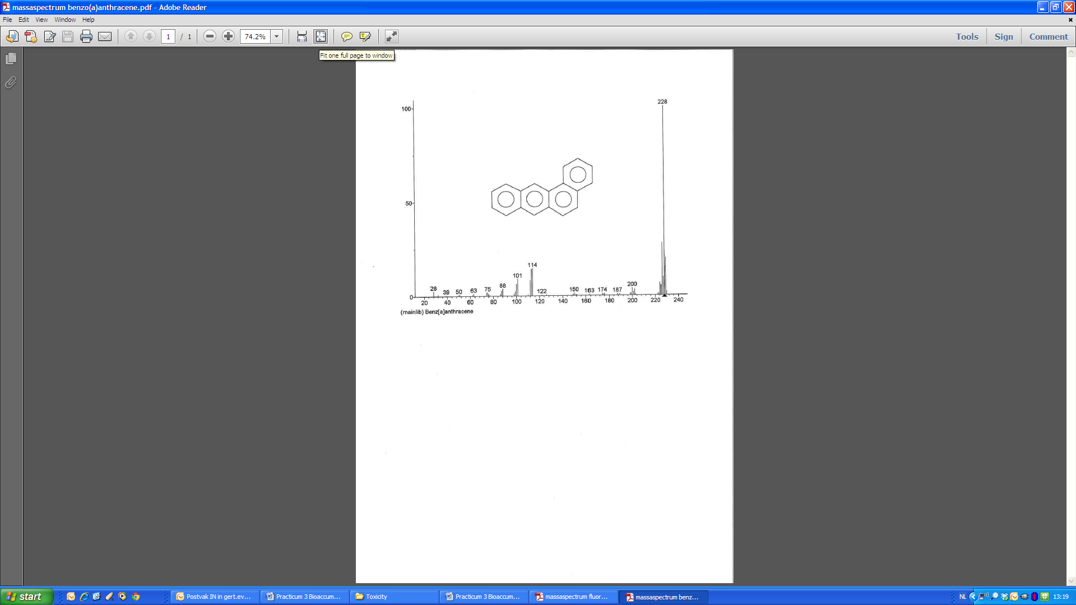

**Figure 5.11 MS-spectrum benzo(a)anthracene**

**Step 10a: Quantification of PAHs** **in water samples**

When you read a result from the GC this value should be recalculated because part of the chemical of interest is not recovered. To do this, you can make use of the amount of IS (added at the start of the procedure) that is recovered in the GC. This can be calculated as (check units!):

(6)

With:

* CIS, theor,ext = theoretical IS-concentration of extract (ng/ml)

* VIS = volume of the internal standard solution (µL)

* CIS  = Concentration of the internal standard solution (µg/mL)

* Vend = end volume extract (mL)

For instance, assume that you added 10 µL of IS (VIS) with a concentration of 11.54 µg/mL (CIS, stand, so you added 0.1154 µg IS. Assume that the end volume of the extract (Vend) was 1 mL, this means that 0.1154 µg is dissolved in 1 mL of extract. So, the theoretical IS-concentration in the extract (CIS, theor,ext) is 115.4 ng/mL.

Now, assume that the result of the GC indicates that the concentration of IS is 52.4 ng/mL. This means that due to the followed procedure 55.6% of the standard IS was lost, or in other words, you have an recovery of 45.4%. Assuming that the recovery is the same for our chemical of interest, we can calculate the actual concentration in the sample. For instance, assume that the GC-result for BAA is 181.6 ng/mL and that the volume of the sample before evaporation (*Vsample*) was 0.108 L. Based on these data you can calculate that the concentration of BAA in the sample under study is 3.70 µg/L (assume Vend = 1mL and an efficiency of 45.4%). This can be calculated via:

(7)

With:

* Cwater = Concentrations chemical X in the water (µg/L)

* Vsample = volume sample before extraction (L)

* Vend = end volume extract (mL)

* GC-result test substance = result of the GC-analysis of the test substance (ng/mL)

* CIS, theor,ext = theoretical IS-concentration of extract (ng/ml)

* GC-result IS, extr = result of the GC-analysis of the internal standard solution (ng/mL)

**Step 10b: Quantification of PAHs** **in mussels**

When you read a result from the GC this value should be recalculated because part of the chemical of interest is not recovered. For this you can make use of the amount of IS (added at the start of the procedure) that is recovered in the GC. For instance, assume that you added 50 µL of IS (VIS) with a concentration of 40.39 µg/mL (CIS, stand), so you added 2.02 µg standard IS. Assume that the end volume of the extract (Vend) was 1 mL, this means that 2.02 µg is dissolved in 1 mL of extract. Using equation 6 it can be calculated that the theoretical concentration of the IS is 2.02 µg/mL.

Assume that the result of the GC indicates that the concentration of IS is 1.26 µg/mL. This means that due to the procedure followed 37.6% of the IS was lost, or in other words, you have an recovery of 62.3%. Assuming that the recovery is equal for our chemical of interest, we can calculate the actual concentration in the sample. For instance, assume that the GC-result for BAA is 1.68 µg/mL and the wet weight of the sample (M*sample*) 0.99 g with an assumed fixed dry matter fraction (fDM) for mussels of 0.27. Based on these data you can calculate that the concentration of BAA in the sample under study is 10.1 mg/kg DS (assume Vend= 1mL, and a recovery of 62.3%). This can be calculated based on equation 8.

(8)

With:

* Corg = Concentrations substance X in the mussel (mg / kg DM)

* Msample = mass organism (g)

* Vend = end volume extract (mL)

* fDM = dry matter fraction of the sample

* GC-result test substance = result of the GC-analysis of the test substance (ng/mL)

* CIS, theor,ext = theoretical IS-concentration of extract (ng/ml)

* GC-result IS, extr = result of the GC-analysis of the internal standard solution (ng/mL)

## 5.4. PCLAB: Calculations and data processing

## Consider the uptake phase of a bio-accumulation test with fish.

## 🡪 Calculate the expected time to reach 80% and 95% of the steady state (t80 and t95) for BAA and FLU, based on equations 3 and 5.

1. Theoretical exercise on the use of passive samplers
   1. Preloading of the samplers

In a jar containing 150mL of MeOH solvent, 27.4 g plastic sampler are preloaded by adding 118.2 mg BAA (Ksampler/solvent = 0.4 L solvent/kg sampler). Assume that the chemical only partitions between sampler and water, so no losses due to (a) volatization, (b) biotic or abiotic degradation or (c) adsorption to the wall of the jar.

🡪 Assuming that after two days the steady state conditions are reached, calculate) the total amount (in mg) of BAA loaded to the passive samplers?

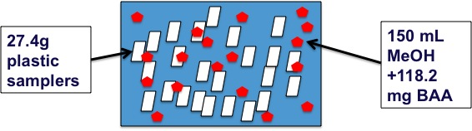

* 1. Use of passive samplers

Assume that 5.29 g BAA-preloaded (similar as in exercise B.a) passive samplers are added to a volume of 1.5L sea water containing 5 mussels with an average wet weight of 1.31 g per mussel and a fat content of 5%. Assume that BAA only partitions to the fat of the mussel, not to the other tissues.

Partition-coefficients for BAA:

* + - * Log Kow = 5.52 (Lwater/kgoctanol)
      * Log Ksampler/water = 5.31 (Lwater/kgsampler)

🡪 Calculate the expected aqueous concentration of BAA at steady state.

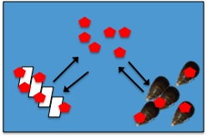

🡪 Calculate the concentration of BAA in the mussel at steady state.



🡪 Calculate the concentration of BAA in the water in a situation without the mussels in the water.

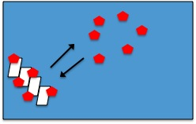

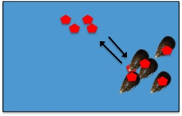🡪 Calculate the concentration of BAA in the water at steady state in a situation without the passive samplers in the water and with an initial concentration of BAA in the water equal to the steady-state concentration of BAA in the presence of the passive samplers (ie. Steady-state concentration calculated for the previous question).

1. Calculate the PAH concentration in the seawater samples and the mussel tissue based on equations 6,7 and 8 (for data, see Minerva).
2. Calculate, compare and discuss the BCF values for the different chemicals. Assume an average dry matter content of the mussels of 27% (for data, see Minerva).

|  |  |  |  |  |  |
| --- | --- | --- | --- | --- | --- |
| Experiment | Chemical | Test concentration Cw (µg/L) | Cmussel at SS  (mg/kg DS) | Cwater at SS  (µg/L) | BCF (L/kg wet weight) |
| 1 |  |  |  |  |  |
| 2 |  |  |  |  |  |
| 3 |  |  |  |  |  |
| 4 |  |  |  |  |  |
| 5 |  |  |  |  |  |
| 6 |  |  |  |  |  |
| 7 |  |  |  |  |  |
| 8 |  |  |  |  |  |
| 9 |  |  |  |  |  |
| 10 |  |  |  |  |  |

1. Make a graph in which you plot the log BCF values of the chemicals against their log Kow and also against the Cw. Does the observation match the expectation based on theory? Explain.
2. Dropbox your results to Olivier Berteloot

**Supportive information**

Connell, D.W., and D.W. Hawker. 1988. Use of polynomial expressions to describe the bioconcentration of hydrophobic chemicals by fish, Ecotoxicol. Environ. Saf. 16, 242-257.

Kilian E.C. Smith, Nathalie Dom, Ronny Blust, Philipp Mayer. 2010. Controlling and maintaining exposure of hydrophobic organic compounds in aquatic toxicity tests by passive dosing. Aquatic Toxicology 98, 15–24.

# Klaus Mittendorf, Laslo Hollosi, Ebru Ates, Katerina Bousova, Eric Phillips, Hans-Joachim Huebschmann, James Chang. 2010. Determination of Polycyclic Aromatic Hydrocarbons (PAHs) and Aliphatic Hydrocarbons in Fish by GC-MS/MS. Thermo fisher Scientific Inc. Protocol AN51991.

OECD 2011. Guidelines for testing chemicals. Report 305.