# Practicum 4: Human Toxicology: Human Exposure & Human Risk Assessment

**4.1. Exposure modelling tools**

Exposure modeling tools are used to estimate exposure, e.g. at the workplace, for consumer products, in the environment, in the absence of measured and/or analogous data.

Depending on their level of refinement and possible applications, we can distinguish Tier 1 and Tier 2 tools:

* **Tier 1** tools only require very basic information as input, are generally easy to use and usually used for ‘screening purposes’, to identify “situations potentially at risk”. They generate estimates that are more conservative than the ones generated by Tier 2 tools.
* **Tier 2** tools require more detailed input information and a better knowledge of the exposure determinants, but generate more precise estimates. They may be more difficult to handle.

Users of exposure estimation tools should keep in mind that most tools are of a very conservative nature (i.e. in most cases they tend to the cautious, higher side of exposure estimates) and that they are only validated to a limited extent and/or for some uses. Application of higher tier models in particular will in many situations require in depth understanding of exposure estimation and expertise in handling the tools to avoid highly inaccurate estimates.

**4.1.1. Examples and exercises on Tier 1 tools**

***4.1.1.1. EMKG***

The EMKG exposure assessment tool (EMKG-EXPO-TOOL, MS Excel®) is part of the “Easy-to-use workplace control scheme for hazardous substances” of the German Federal Institute for Occupational Safety and Health (BAuA).

The tool uses a “banding approach” for the exposure assessment (largely based on a UK system named Control of Substances Hazardous to Health Regulations).

The concept of banding means here that both input data and the result are expressed in categories (bands), which often differ by at least one order of magnitude

The tool estimates **inhalation exposure only.**

The tool consists of three different worksheets, one detailing the limitations, one for

solids and one for liquids. Application of the tool is straightforward and (with the exception of alternative input for boiling point and operating temperature) only requires the user to click a limited number of fields (e.g. “Medium” in the volatility band)

**Steps:**

1. define dustiness (solids) or volatility (liquids), i.e. tendency to become airborne
2. indicate the scale of use band (amount of substance)
3. select control strategy

**Exercise:**

*Situation: A company X manufactures a range of furniture from wood and metal. The furniture is spray painted with Product C by an operator in front of a spray wall in the workshop (>1m). The spray wall provides localized ventilation. There is mechanical ventilation in the workshop. The process takes place at room temperature (20oC).*

*Product C contains 80% toluene. There is no personal protective equipment or respiratory protective equipment worn during the activity.*

*The task is undertaken for 6 hours out of an 8 hour shift.*

|  |  |  |  |  |  |  |
| --- | --- | --- | --- | --- | --- | --- |
| **Product** | **Supplier** | **Substance Name** | **CAS Number** | **Molecular Weight (g∙mol-1)** | **Vapour pressure at 20°C (Pa)** | **Concentration of toluene in Product C (%)** |
| **Product C** | **Supplier C** | **Toluene** | **108-88-3** | **92** | **2800** | **80** |

**Step 1: Open the Tool**

The tool is a Microsoft Excel 97-2003 Worksheet. To open the tool, double click on the file “EMKG-EXPO-TOOL.xls”.

The tool will then start. Enable macros, Editing or Contents if asked.

Before starting, read the “**Limitations**” sheet.

**Step 2: Entering Data**

There are two data entry sheets in the EMKG-EXPO-TOOL, one for assessing exposures to solids and one that can be used for liquids. Only one of these sheets is required per situation. Please choose by clicking the relevant data entry sheet.

Data are entered on these sheets by clicking on the left hand side box for each option, for example low/medium/high/1/2/3). The boxes will change color as you click on them.

The help function is accessed by clicking on the cells containing a question mark (?)

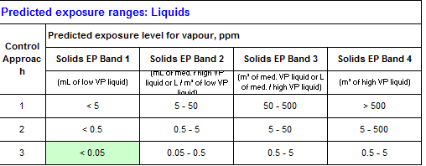Enter the required data from the exposure situation described above, to generate predicted exposure level ranges. These are shown in a coloured box in the table at the bottom right hand side of your screen, as indicated in the circle on the example screenshot below.

**Warnings:**

The tool has limitations and makes a number of conservative assumptions:

* The concentration of a substance (in a preparation) is assumed to be 100%.
* The exposure duration is assumed to be full shift length (with the only exception of

exposures below 15 minutes).

In addition, the user should select more conservative parameters whenever uncertain about a particular input.

***4.1.1.2. MEASE***

MEASE (http://www.ebrc.de/industrial-chemicals-reach/projects-and-references /mease.php) aims at providing a Tier 1 screening tool for the estimation of inhalation and dermal exposure to metals and inorganic substances at the workplace.

The tool is based on Process Codes (PROCs) as defined under REACH. Those PROCs correspond to workplace situations

For inhalation exposure, the tool selects initial exposure estimates from three so-called "fugacity classes". The exposure estimates for PROCs 21-27a in MEASE are based on measured data from the metals industry.

For dermal exposure, MEASE is based on the classification system of another broadly used tool named EASE but the exposure estimates are based on real measured data for several metals.

MEASE gives users the possibility to choose between several Risk Management Measures.

**Exercise**

*Situation: Casting of aluminum into blocks.*

*Molten aluminum (Product W) is siphoned from the bottom of a furnace by the operator, then transported in open containers (crucibles) to a holding furnace before being cast into blocks. The melting point of aluminum is 660oC. Casting takes place at a temperature of 700°C. The whole of the situation described above takes place in Work Area W.*

***Product/ substance Information:***

|  |  |  |  |  |  |  |
| --- | --- | --- | --- | --- | --- | --- |
| **Product** | **Supplier** | **Substance**  **Name** | **CAS Number** | **Molecular weight(g∙mol-1)** | **Vapour pressure at 20oC (Pa)** | **Concentration of aluminum**  **in Product W (%)** |
| Product W | Supplier W | aluminum | 7429-90-5 | 27 | 1 (Negligible) | 100 |

**Step 1: Open the Tool**

The tool is a Microsoft Excel 97-2003 Worksheet.

To open the tool, double click on the file “MEASE-1.02.01.xls”. The file may instead be called “MEASE-1.02.01” depending on your computer set up.

The tool will then start. Enable macros, Editing or Contents if asked.

Before starting, please read the “Glossary” sheet by clicking on the “Glossary” tab at the bottom of the page.

**Step 2: Entering Data**

The main sheet for all data entry is the “MEASE” sheet. Data is entered directly into the grey input fields or selected from the drop down lists.

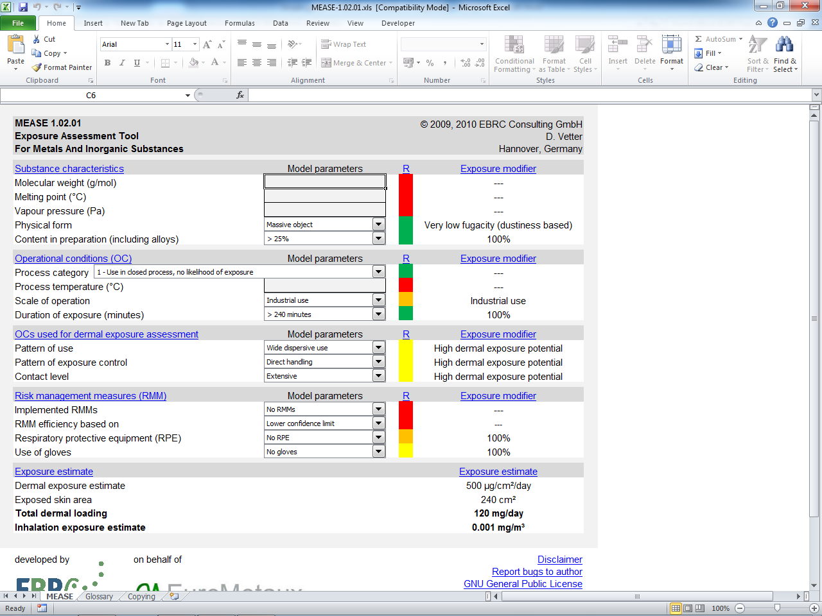

Enter the required information from the exposure situation description into the sheet.

This will generate estimates of inhalation and dermal exposures at the bottom of the sheet, as shown within the circle above.

**4.1.2. Examples and exercises on Tier 2 tools**

**4.1.2.1. RiskofDerm**

This tool evaluates dermal exposure to a preparation with a differentiation of exposure of the hands and exposure of other parts of the body. If you are handling a preparation, exposure to the constituents of the preparation has to be calculated by multiplying the exposure to the product with the fraction of the constituent in the product.

The brief “Explanation” worksheet is important and should be consulted before using the tool.

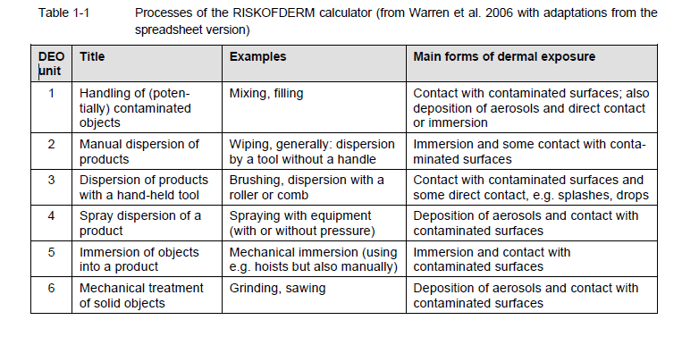

**Exercise**

*Situation: Re-filling of Dry Cleaning Equipment with 1-Bromopropane in Retail Premises*

*This situation describes the refilling of dry cleaning machines with 1-Bromopropane solution. The activity takes place in small retail premises in Work Area Y, at room temperature (20oC).Machine operators refill the dry cleaning machines with Product N containing 1-Bromopropane (80%). Around 10 liters of product is added. The operator does not wear any respiratory protective equipment. Rubber gloves are worn. There is general ventilation in the shop. The task is undertaken for 30 minutes per 8 hour shift.*

***Product/ Substance Information***

|  |  |  |  |  |  |  |
| --- | --- | --- | --- | --- | --- | --- |
| **Product** | **Supplier** | **Substance Name** | **CAS Number** | **Molecular weight**  **(g∙mol-1)** | **Vapour pressure at 20°C(Pa)** | **Concentration of 1-bromopropane in Product N (%)** |
| **Product N** | **Supplier N** | **1-Bromopropane** | **106-94-5** | **123** | **14800** | **80** |

**Step 1: Open the Tool**

The tool is a Microsoft Excel 97-2003 Worksheet.

To open the tool, double click on the file “RISKOFDERM potential dermal exposure model vs 2.1t.xls”. The file may instead be called “RISKOFDERM potential dermal exposure model vs 2.1t” depending on your computer set up. The tool will then start. Enable macros, Editing or Contents if asked.

The main sheet for all data entry is the “Start” sheet.

If this sheet is not displaying (the “Process” sheet might be showing) and the “Start” tab at the bottom of the page is not available, perform the following.

Move the mouse top the top menu bar and click on File 🡪 Exit

The screen display should now be showing the Start sheet and a popup box will be asking if you want to “**Save the changes you made**”. Click the Cancel button. You will now be able to use the tool from the “**Start**” sheet.

**Step 2: Entering Data**

Before starting, please read the notes on the “**Start**” sheet and the “**Explanation**” sheet.

To enter data, click on the grey “**Go to the choice of process**” button (shown in the red circle in the screenshot above).

The relevant data entry sheet for the activity you are assessing is chosen by clicking on the relevant process button on the “**Process**” sheet, for example “**wiping**”. You will need to decide on which process fits the exposure situation best.

**4.2. Derivation DNELs and Risk Characterization Ratio**



Effect level= DNEL

Exposure level

The **Derived No-effect Level** (DNEL) is the level of exposure above which humans should not be exposed. It shall be considered as an overall NOAEL (No-(Adverse)-Effect-Level) for a given exposure and accounting for uncertainties/variability of the data and the human population exposed.

Under REACH, DNELs must be derived for all substances subject to registration manufactured/ imported/used in quantities of ≥10 T/year.

“DNELS shall be established for the substance, reflecting the likely route(s), duration and frequency of exposure”. It may be necessary to identify different DNELs for each relevant human population (e.g. workers, consumers, man exposed via the environment) AND for different routes of exposure.

**How can we derive DNELs?**

* You need data: all effects data shall be evaluated. Dose descriptors (N(L)OELs, Benchmark dose etc.) need to be established
* You need to address uncertainty/variability: the difference between effect assessment data and the real human exposure situation must be addressed by applying Assessment Factors (AF).
* You need to assess different populations and exposure routes: workers, general population
* You need to consider the duration of exposure: long term or acute ?
* You need to consider systemic and/or local effects
* Units: by default, DNELs should be expressed in external exposure values. However, internal values (i.e. biomonitoring) can also be used if available and reliably associated with effects (DNELbiomarker)

**Stepwise approach:**

**Step 1: Gather dose descriptors e.g. N(L)OAEL, LD50, LC50**

It is possible that for a particular endpoint data from more than one study are available and that the studies are all relevant and appropriate: need for expert judgment and weight of evidence

**Step 2: derive DNEL by selecting the relevant dose-descriptors & applying assessment factors**

1. Select the relevant dose-descriptor for the endpoint concerned
2. Apply **assessment factors** (AF) to the correct starting point to obtain endpoint-specific DNELs for the relevant exposure pattern

The overall assessment factor is obtained by simple multiplication of the individual assessment factors. The overall AF is to be applied directly to the dose descriptor in the following manner:

*Endpoint-specific DNEL :*

|  |  |  |  |
| --- | --- | --- | --- |
| **Type of AF** |  | **AF** | **comments** |
| **Interspecies differences** | Differences in metabolic rate with humans | 2.4 (rabbit)  4 (rat)  7 (mouse) | Not if effects not dependent on metabolic rate/systemic absorption (acute tox, local effects) or if starting point is human data |
| Other interspecies differences | 2.5 |  |
| **Intraspecies differences** | Workers  General population | 5  10 | A higher AF should be considered when there are indications of effects on organ systems and functions especially vulnerable under development and maturation in early life and /or deficiencies in the database on such effects in young animals |
| **Exposure duration** | Sub-chronic (90-day) to chronic (2y.)  Sub-acute (28-day) to sub-chronic  Sub-acute to chronic | 2  3  6 | Takes into account that: a) in general the experimental NOAEL decreases with increasing exposure times, b) that other effects appear with increasing exposure time  Substance-specific information may be used to modify the default values, upwards or downwards (e.g. for some local or dermal effects, for potential accumulation) |
| **Dose-response relationship** |  | 1-10 | Takes into account the dose spacing, the shape and slope of dose-response curves and the severity of the effect seen |
| **Quality of the whole database** |  | 1-10 | Takes into consideration reliability, consistency, alternative data (in vitro, QSAR, read across, chemical categories) |

**Step 3: Risk characterisation: comparison of the exposure of each population with the appropriate DNEL**

**RCR =**

If Exposure< DNEL, risk is controlled

If Exposure>DNEL, risk is NOT controlled

**Exercise:**

*Derive a DNEL for Substance X (only oral route, repeated dose exposure in this case, for workers and general population) and calculate the RCR knowing that typical values for exposure are: 0.31 mg/kg bw/day for general population and 0.54 mg/kg bw/day for worker.*

The data are summarized below and estimated to be of good quality:

|  |  |  |
| --- | --- | --- |
| **Data/method** | **Results** | **Reference** |
| Rat (Sprague-Dawley) male/female  3 generation study; oral: diet (104 weeks) | NOAEL for testicular toxicity and developmental. toxicity 4.8 mg/kg/day, and 46 mg/kg/day for fertility.  Dose-dependent effets on numerous testis-related parameters. | Z & A, 2008 |
| Rat (Fischer 344) male/female; chronic (oral: diet) | NOAEL: 500 ppm (male/female) (NOAEL = 28.9 mg/kg bw/day [males] and 36.1 mg/kg/day [females] | Zorro, 1996 |

**Step 1: Gather dose descriptors e.g. N(L)OAEL, LD50, LC50**

Endpoint: NOAEL: ….

Endpoint: NOAEL: ….

**Step 2: Calculate the DNEL by applying assessment factors**

|  |  |  |
| --- | --- | --- |
| **Type of AF** |  | **AF** |
| **Interspecies differences** | Differences in metabolic rate | 2.4 (rabbit)  4 (rat)  7 (mouse) |
| Other interspecies differences | 2.5 |
| **Intraspecies differences** | Workers  General population | 5  10 |
| **Exposure duration** | Sub-chronic (90-day) to chronic (2y.)  Sub-acute (28-day) to sub-chronic  Sub-acute to chronic | 2  3  6 |
| **Dose-response relationship** |  | 1-10 |
| **Quality of the whole database** |  | 1-10 |

**Step 3: Risk characterisation: comparison of the exposure of each population with the appropriate DNEL (Calculate the RCR)**

**Workers :**

**General population :**